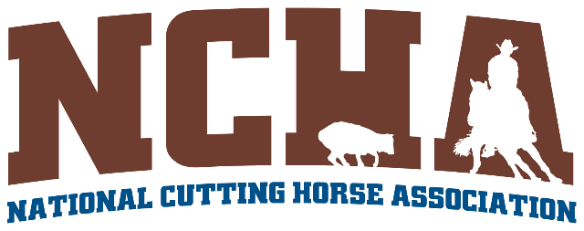

NCHA FUTURITY BOX SEAT HOLDER POLICY
(APPROVED BY EXECUTIVE COMMITTEE ON 8.9.17)

- NCHA Box Seats are sold on an annual basis with the previous year's owner having first right of refusal to renew. The name listed as a Box Seat Holder (BSH) must be a current member of the NCHA.
- Annual renewal of Box Seats must be confirmed in writing/email.
- BSH’s are permitted to sell their boxes to others but the BSH is responsible to pay for the Box Seats.
- If Box Seats are not renewed, the Box Seats will be offered to the next name, with a current membership, on the waiting list. If the person(s) next on the list refuses to purchase the available tickets the person(s) name goes back on the bottom of the list.
- Upon death to a BSH, his or her Box Seats can be retained by the immediate family (spouse or surviving children). Box Seats may NOT be "handed down" or signed over to other relatives or associates. If a box is listed under a company or farm name, the person signing the membership is considered the BSH.

